

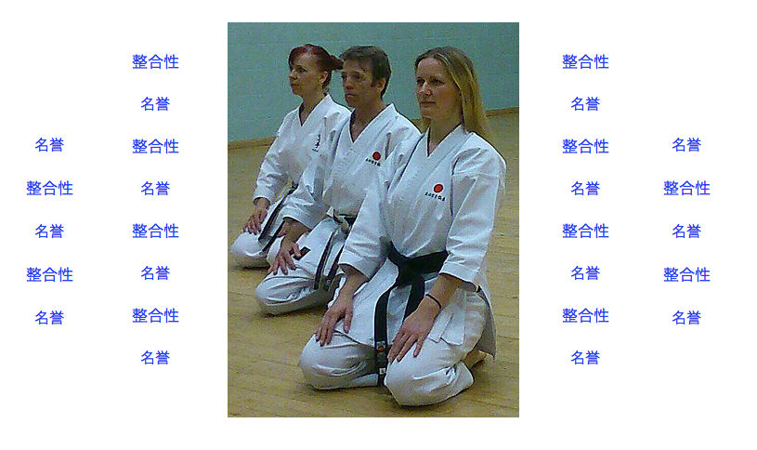

**SSK invite you to train at one of our local classes**

**Mondays, Wednesdays, Fridays and Saturdays**

**For more information visit** [**www.sskglasgow.com**](http://www.sskglasgow.com)

**or**

**Telephone Sensei Jamie McGreechin on 07944 446260**